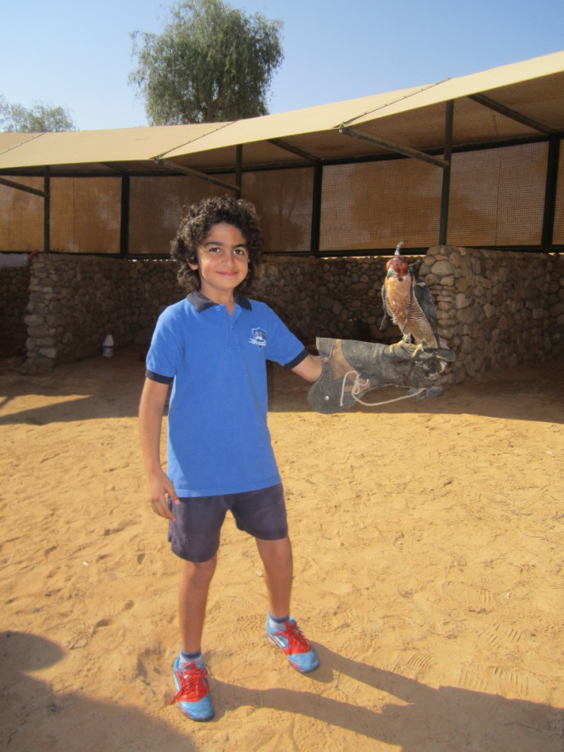

4A went to the Banyan Tree Resort as part of our unit of inquiry. We learnt about the importance of a balanced lifestyle. We must make sure that we are having a healthy, happy life. When we visited the Banyan Tree we learns we also learnt that we have to be thoughtful about the choices that we make towards our environment and how our actions help to make our world a better place.

Abdelrahman B Abdelrehim 4A

